**Patch Design:**

On this document you will find a blank allotment plot.

You can add anything you think our community allotment might need!

Some ideas of what you could add are as follows:

* Flowers
* Vegetable beds
* Mini Pond
* Seating
* Mini Shed
* Decorations

All ideas are welcome and we can help use these designs for the final plot at Patching Meadows.

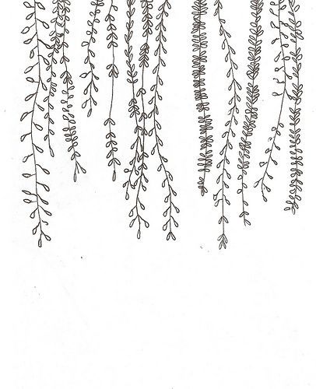

Feel free to **print** or **design digitally** and send all completed plot designs to childrenreferrals@aspens.org.uk